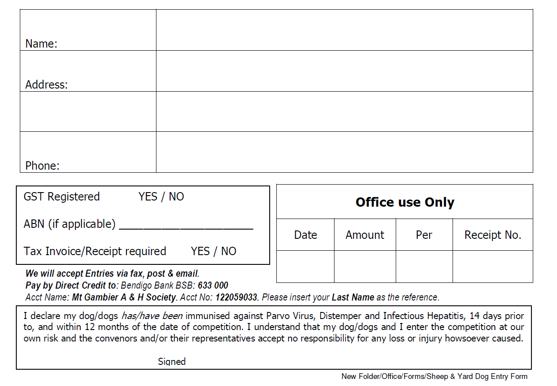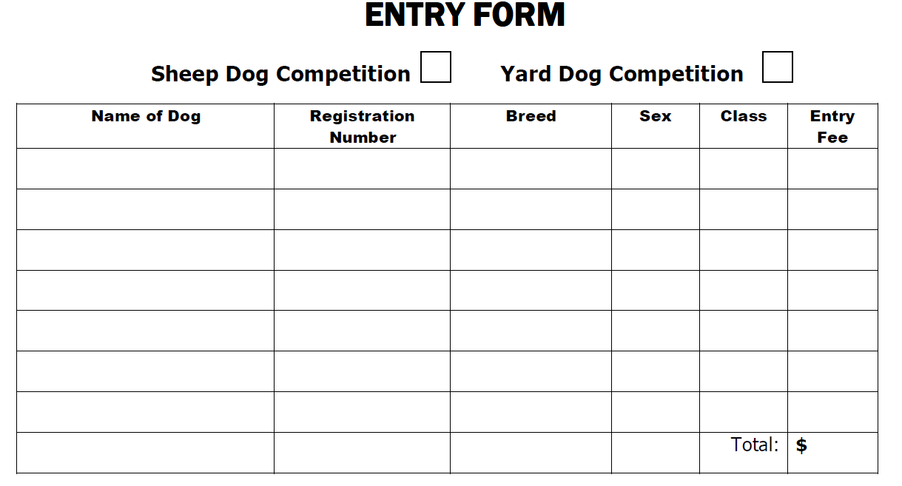

**Mount Gambier A & H Society Inc.**   
**PO Box 106, Mount Gambier SA 5290**  
**T:** 08 8725 1873 **Fax:** 08 8724 9461 **Email:** admin@mgshow.com.au