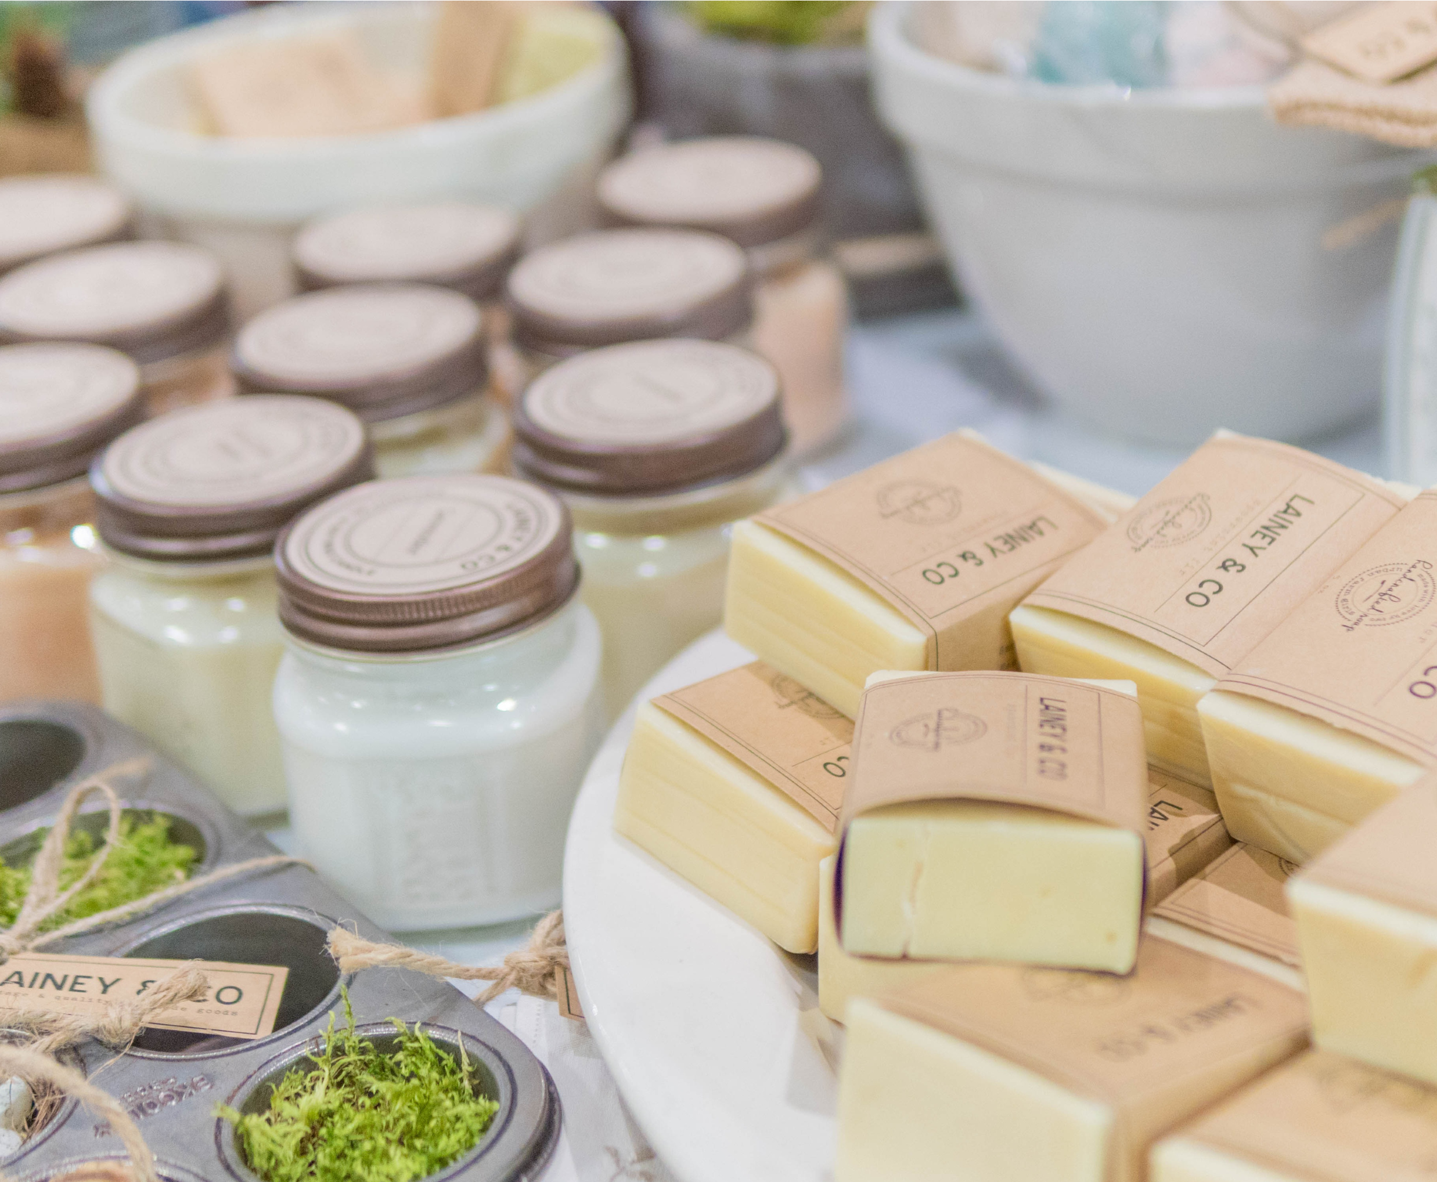
WINTER MARKETS 2022
MT GAMBIER SHOWGROUNDS
SUNDAY JULY 10TH 2022
Mount Gambier Showgrounds, Pick Ave.
Mount Gambier SA

WINTER MARKET 2022
PROPOSED
OPENING TIMES
Sunday July 10th 2022
9
am - 1 pm
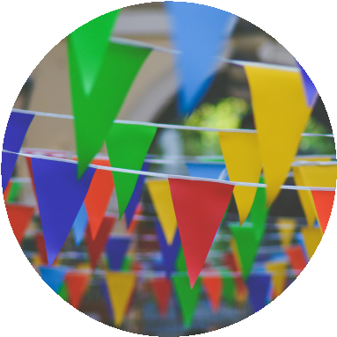
STALL SITES
Indoor/Outdoor
All sites are 3m x 3m.
Limited indoor and outdoor sites available.
We do not supply any equipment for stall holders.
Indoor site $55.00 | Outdoor site $33
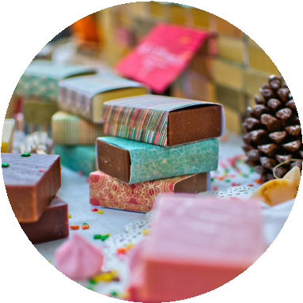
STALL TYPES
Indoor/Outdoor
Both Indoor and Outdoor sites will have access to electricity.
Water outlets will be available for Outdoor sites only.

ENTERTAINMENT
We encourage buskers to get in contact to discuss options.

ADVERTISING
The Mt Gambier A & H Show Society will actively advertise the event via social media.
Stallholders will be individually featured a minimum of 1 time in the 4-week period leading to the event via social media.

WINTER MARKET 2022
TERMS &
CONDITIONS
Sunday July 10th 2022
9
am - 1 pm
STALL SITES
- The A & H Society reserves the right to refuse any stall booking. No correspondence will be entered into.
- Sites will ne allocated by the Stall site co-ordinator. Stallholders MUST use the stall site allocated to them. Site locations will not be amended.
- Food vendors will have priority locations as they may need electricity and water.
- Stall holders are to present stands and staffing to a high standard.
- It is the responsibility of the Stallholder to ensure their gazebo or marquee are securely weighted.
- Stallholders are responsible for the disposal of all waste materials in an appropriate manner. All packaging and product waste is to be removed from the site by the stallholder.
- Stallholders are to supply their own lighting. Indoor sites will be lit by the existing lighting.
- Stalls MUST NOT be pulled down prior to 1pm on Sunday July 10th (if sold out stalls can be tied up /closed ready for pull down).
- Bump in available Saturday 9th July between 2pm – 4pm or Sunday 10th July between 7am – 8:30am. All vehicles must be cleared by 8:30am Sunday morning.
- Bump out Sunday 10th July after 1:30pm.
- Stallholder must supply a copy of their current Public Liability Insurance. This can be purchased through the A & H Society for $20 if you do not have your own existing insurance.
CANCELLATIONS

- Cancellations after July 1st 2022 will result in nil refund.
- Cancellations received prior to July 1st 2022 will attract a refund less administration fee of $20.
- The Mt Gambier A & H Society Inc. will not be liable for any loss incurred by a stallholder or for the refund of any fees if the event does not proceed for any or all of the program due to inclement weather or any other factor beyond the control of the Mt Gambier A & H Show Society Inc.

